# Spot

Project Documentation Submitted

to the Faculty of the

School of Computing and Information Technologies

of

Asia Pacific College

In Partial Fulfillment of the Requirements for the subject

Applied Projects 2 or Software Development

By

Ma. Eryel Gianca A. Cells

Benedict M. Agno

Jejomar B. Politico

**ASIA PACIFIC COLLEGE**

# Approval Sheet

SPOT

Prepared and Submitted by:

Ma. Eryel Gianca A. Cells

Benedict Agno

Jejomar Politico

In Partial Fulfilment of the Requirements for the Degree of

Bachelor of Science in

Examined and Recommended for Acceptance and Approval for Research/Capstone Presentation

___________________________

Adviser

Panel of Judges

___________________________

Chairperson

Panel Members

___________________________ ___________________________

Panel Member Panel Member

Acceptance and Approved in partial fulfillment of the requirements for the degree of Bachelor of Science

_______________________________

Executive Director

School of Computing and Information Technologies

Table of Contents

Spot 1

Approval Sheet 2

Executive Summary 4

List of Figures, List of Tables, List of Notations 5

I. Introduction 6

1.1 Project Context 6

1.2 Purpose and Description 7

1.3 Objectives 8

1.4 Scope and Limitations 8

II. Review of Related Literature/Systems 9

III. Technical Background 10

IV. Methodology, Results and Discussion 12

4.1 Requirements Analysis 12

4.2 Gap Analysis 12

4.3 Design of Software, Systems, Product, and/or Processes 13

4.4 Development and Testing, where applicable 31

4.6 Description of the Prototype, where applicable 31

4.7 Implementation Plan (Infrastructure/Deployment) where needed 35

4.8 Implementation Results, where applicable 35

V. Conclusion and Recommendations 35

VI. Appendices 36

VII. References 42

# Executive Summary

Spot is a mobile application for Android devices that works with the help of camera to identify objects which are related to technology. Spot runs with the use of A.I. or artificial intelligence which is powered or came from OpenCV (Open source computer vision) API. The application will give information about the object such as the name of the object, description, how the object is being used and a brief history of the object. Unlike the existing similar applications, Spot has a lot of information to give out and it will beneficial for the people specially for the visually impaired to gather information and have the knowledge with the simple things unknown that they usually encounter which has something to do with technology.

# List of Figures, List of Tables, List of Notations

Figure 1 - Sift (Scale-invariant feature transformation) Algorithm 10

Figure 2 - FAST (Features from Accelerated Segment Test) Algorithm 10

Figure 3 - Functional Decomposition Diagram 13

Figure 4 - Data Flow Diagram 14

Figure 5 - Entity Relationship Diagram 15

Figure 6 - Class Diagram 16

Figure 7 - Use Case Diagram 17

Figure 8 - Capture Image (Activity Diagram) 20

Figure 9 - Save image to data image (Activity Diagram) 21

Figure 10 - Image Scanning (Activity Diagram) 21

Figure 11 - Compare image to data image (Activity Diagram) 22

Figure 12 - Get matched image information (Activity Diagram) 23

Figure 13 - Sequence Diagram 24

Figure 14 - Object Diagram 25

Figure 15 - State Diagram 25

Figure 16 - Timing Diagram 25

Figure 17 - Communication Diagram 26

Figure 18 - Package Diagram 26

Figure 19 - Component diagram 27

Figure 20 - Deplyoment Diagram 28

Figure 21 - Composite Diagram 29

Figure 22 - Interaction Diagram 30

Figure 23 - Splash Screen Activity 31

Figure 24 - Main Activity 32

Figure 25 - Camera Intent Activity 33

Figure 26 - Result Activity 34

Figure 27 - Splash Screen Activity (Source code) 36

Figure 28 - Main Activity (Source code) 36

Figure 29 - Result Activity (Source code) 37

Table 1 - Gap Analysis 13

Table 2 - userImage table (ERD) 16

Table 3 - dataImage table (ERD) 16

Table 4 - imageInformation table (ERD) 16

Table 5 - Capture Image (Use Case Diagram Fully Dressed) 19

Table 6 - Save image to database (Use Case Diagram Fully Dressed) 19

Table 7 - Image Scanning (Use Case Diagram Fully Dressed) 20

Table 8 - Compare image to data image (Use Case Diagram Fully Dressed) 20

Table 9 - Get matched image information (Use Case Diagram Fully Dressed) 21

# Introduction

## Project Context

Spot project is an object identifier. It contains A.I. or Artificial Intelligence which helps the application identify an object. It requires Android phone with camera with WIFI or 3G / 4G / LTE connection to be able to use the application. All you need to do is to point the camera to an object related to technology that you want to identify and it will automatically scan what it looks like, and gives percentage of what the object is. The information will not only focus on the visual details but it will also give its name, description, usage of the object, and a brief history about it.

The project is inspired by the Imagine Cup Philippines Grand Winner Team Opticode, from Lyceum of the Philippines Laguna. Project “Minerva” is a virtual assistant mobile application that is designed for visually impaired people. The said application is made to help people suffering from color blindness. The application lets the user point out a finger to specific object on the screen within the view of camera to identify its color, and then the application will speak the color of it.

Spot will also convert the text to speech for the user can not just only see the information at the screen but also hear what is written and projected at the phone’s screen. Information or results given by the application can also be change from the user’s desired language. The images that the Spot scans or scanned will also be saved and collected for the offline usage of the application.

## Purpose and Description

The growth and development of Information Technology sector in the Philippines is assessed to be one of the best in global scale as for today’s time. Every person nowadays even children are using different technology materials like gadgets. IT professionals, non- IT professionals and non- IT are part and are beneficiaries of Information technology as it is being used in different ways now. The IT BMP Industry of the Philippines is continuously growing section or division which provides thousands of jobs in the country. This rapid growth and development of the workforce affects different jobs, employees and sectors as the IT division is usually using and requiring 67% of job which has something to do with IT.

Synthesizing the conditions and happening in the Philippines, it is understandably that computer education has lessen due to the circumstances. Even though the computer education is implemented by the government, computer education still does not exist in some schools. The high cost of equipment and lack of space limit most public schools in the Philippines to implement and have the certain awareness level to computer education. There are some schools who are funded by companies who provides equipment to have better awareness level for computer education.

In contrast with public schools, computer education is more normally available at private schools in the Philippines. Elementary, secondary and post-secondary institutions offer courses or subjects of set quality about computer education. According to Flores, head instructor in Ateneo, even though equipment and tools are provided to private schools, they are still anticipated problems in computer education in their society because of teacher resistance, and usually right usage of equipment.

Last year 2017, Microsoft released a video clip that shows an example of how technology or computer education can lead and empower those students with special needs. It is stated in their approach that digital transformation is eating and continues to come by all industries, including education. According to Asia Digital Transformation Study that has been done across 13 markets in Asia by Microsoft, 87% of the leaders coming from education sector agreed that educational institutions needs to be improved into digital business to empower future growth. Yet, it is now more overriding to the Philippines, which has 25.4 million K-12 learners and fast-growing economy to assure that technology is used to captivate all learners and get them ready for the future.

World Health Organization(WHO) statistics shows that there are 348,771 people in the Philippines are blind, counted there also those who are partially blind. Imagine those people who can see and can study and learn yet has not enough technology or education guidance which can help them, what more are those who are suffering from blindness. This application aims to serve as an aid for those who are visually impaired, but the project could also be beneficial and helpful for those students and different users who are into discovering things about computer education. According to Statista, there would be a range or increase of mobile phone users from 2015 up to 2022, and it is expected or assumed that by 2022 mobile phone users in the Philippines will reach 46.04 million. The project does not give or provide full knowledge to each and every phone users, but it is assumed that learning could grew more and start by simply knowing and understanding computer education.

## Objectives

* To quickly provide information to visually impaired and other users of the application.
* To serve as an educational tool for computer education.
* To improve and to add knowledge about computer education among users of the application

## Scope and Limitations

* English will be the main language used in identifying the object.
* Wi-Fi or 3G/LTE is needed to be able to use the application.
* Recent scans will be covered for offline uses.
* Only known objects about computer education will be analyzed and provided.

# Review of Related Literature/Systems

The following are existing systems related to the project:

**Wolfram Language Artificial Intelligence** is a built system that give computers all kinds of intelligence. For a long time, Wolfram Language have been integrating intelligence, up until it discovered and built “Image Identify”. The system lets the user drag a picture to the web page, snap it with your phone or camera, and or load it from a file and see what Image Identify think it is. (Wolfram, 2015)

**Minerva** is a virtual assistant mobile application for visually impaired people specifically colorblind people. The application was designed and built by the Imagine Cup Philippines champion, Team opticode. The application lets them point their phone at different objects to hear and to tell them what these objects color in specific language. (Reyes, 2017)

**CamFind** is the first mobile visual search engine. It allows the user to search for anything from your mobile phone just by taking a picture. The CamFind is designed to innovate the text-based search powered by CloudSight.ai. The said application was first developed for iOS phones or users. (CamFind, 2016)

**Object Recognition** is a mobile application for Android users created by BadLamb. This application is designed to know what a certain object is. The application lets the user capture an image of an object or anything and tell the accuracy of the artificial intelligence thinks that the image or object looks like a certain object. (BadLamb, 2017)

**iDentifi** is an application that empowers visually impaired individuals to gain more independence in daily task like self -navigating in indoor environments and reading. It uses artificial intelligence to click a photo virtually and piece of text then speaks aloud the description of the image or dictate what is written in the text. The said application is only available for iOS phones or users. (Tukrel, 2016)

The five applications have systems that allows the user give or present an image or subject then lets the system think what the image or subject looks like. Just the same as the project’s system, it modifies or identify what the image might be. The project differs from the three applications as it gives information by determining what the object or image is in a way of providing or telling the user a brief history of the object, usage of the object, its common name and the description of the subject.

# Technical Background

The application is running with the help of an A.I. or Artificial Intelligence from OpenCV (Open source computer vision). The application will be using the SIFT (Scale-Invariant feature transformation) and FAST (Features from Accelerated Segment Test) algorithm, these algorithms will be used for image matching which will came from the user and from them application’s database. The application will also be using a java web application connected to MySQL which will serve as the local host or admin side of the application.

SIFT or scale-Invariant feature transformation algorithm is used to detect scale-space extrema, keypoint localization, orientation assignment, keypoint descriptor and keypoint matching. This features of SIFT is used to find keypoints and descriptors of two images. Usually, SIFT is used to compare and match different images to know how is it look like and how is it the same as the other images.

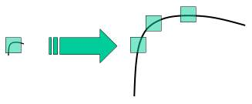

Figure 1 - Sift (Scale-invariant feature transformation) Algorithm

FAST or features from accelerated segment test algorithm has the same function as SIFT but instead of looking for keypoints and descriptors, FAST is using or looking for pixels of the images in comparing and matching them. From its own name, FAST algorithm is used for looking the point of view or goal of the developer as fast as it can.

A picture containing building, indoor

Description generated with high confidence

Figure 2 - FAST (Features from Accelerated Segment Test) Algorithm

The applied algorithms in the application will also be used in analyzing the image being pointed at and defining how sure that the image looks like the images from the application’s database. Next is the application uses the accuracy given to provide the information of the object. The information that will be given will be coming from the admin side of the application which is in the java web application. Recent scans or each scans of the user will also be inserted to the admin side of the application for the history feature of the application.

Spot application is only applicable and runnable for Android OS, since it was built and developed in Android Studio. Android OS was used as the operating system of the application because Android is the most commonly used OS in the market. As per users, this could lead to advantages of the application for Android is the type of OS which is most compatible and found in any devices. This OS cannot just only be found on mobile phones, but can also be found on various gadgets such as tablet, computer, laptop, and etc.

# Methodology, Results and Discussion

## Requirements Analysis

Spot should provide information for the users regarding on the object. The simple but efficient flow and processes will make the application more effective and will provide convenience to the users. These requirements will define how smooth the system will work and how will provide convenience for them. When the user provides the image, Spot will give out necessary information like name, description, usage and brief history of that subject. Spot will surely benefit different types of person and most specifically will help people with disabilities, visually impaired to be exact and will surely give out information as accurate as possible. The object that has been scanned by Spot will be saved and collected for the application to do its job offline.

## Gap Analysis

|  |  |  |
| --- | --- | --- |
| **User Requirements** | **Current System** | **Proposed Changes** |
| The user needs to have an Android phone and the spot application. | The user needs to present an object and capture it. | The proposed application will identify an object. |
| The user requires to have an WIFI or data connection to use the application. | The user must have WIFI or data connection for the application be use. | The proposed application will not identify an object if the object given has nothing to do with technology. |
| The user requires to capture through phone camera an object which the user wants to identify. | The user requires to capture an object then the captured image will be match from the application’s set of data image. | The proposed application will identify, gather and give out information about the object being presented. |
| The user requires to identify desired language to translate information given. | The application does not contain changing of text language | The proposed application will translate the information given in user’s desired language. |

Table 1 - Gap Analysis

## Design of Software, Systems, Product, and/or Processes

1. Functional decomposition diagram

A screenshot of a cell phone

Description generated with very high confidence

Figure 3 - Functional Decomposition Diagram

1. Data flow diagram

Figure 4 - Data Flow DiagramA close up of text on a white background

Description generated with high confidence

1. 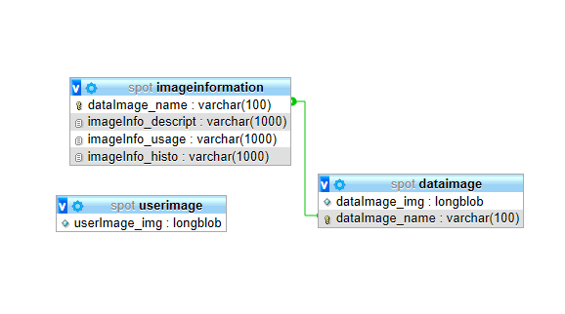Entity relationship diagram (with Data dictionary)

Figure 5 - Entity Relationship Diagram

|  |  |  |  |
| --- | --- | --- | --- |
| **userImage** | | | |
| userImage_img | Not null | Longblob | User’s captured image. |

Table 2 - userImage table (ERD)

|  |  |  |  |
| --- | --- | --- | --- |
| **dataImage** | | | |
| dataImage_img | Not null | Longblob | Sets of computer related object images. |
| dataImage_name | UNIQUE | Varchar(100) | Names of each set of objects. |

Table 3 - dataImage table (ERD)

|  |  |  |  |
| --- | --- | --- | --- |
| **imageInformation** | | | |
| dataImage_name | PK/FK | Varchar(100) | Names of each set of objects in dataImage table. |
| imageInfo_descript | Not null | Varchar(1000) | Object Description |
| imageInfo_usage | Not null | Varchar(1000) | Usage of the object |
| imageInfo_histo | Not null | Varchar(1000) | Brief history of the object |

Table 4 - imageInformation table (ERD)

1. A close up of text on a white background

   Description generated with high confidenceClass diagram

Figure 6 - Class Diagram

1. A close up of a map

   Description generated with high confidenceUse case diagram (fully dressed)

Figure 7 - Use Case Diagram

|  |  |  |
| --- | --- | --- |
| Use Case Name | Capture Image | |
| Scenario | User wants to identify the object | |
| Triggering Event | Object presented | |
| Brief Description | User points the camera to an object and capture the object. | |
| Actors | User | |
| Related Use Cases | None | |
| Preconditions | 1. User should open Spot application. 2. User should allow camera permission. | |
| Postcondition | 1. User had captured an image. | |
| Flow of Activities | Actor | System |
| 1. User presents an object |  |
| 1. User capture an image |  |
|  | 1. Get captured image |
|  | 1. Show captured image |
| Exception Condition | 1. If the user does not allow camera permission. | |

Table 5 - Capture Image (Use Case Diagram Fully Dressed)

|  |  |  |
| --- | --- | --- |
| Use Case Name | Save image to database | |
| Scenario | The system will save the captured image to database | |
| Triggering Event | Get captured image | |
| Brief Description | The system will automatically save captured image to the database | |
| Actors | System | |
| Related Use Cases | None | |
| Preconditions | 1. User should open Spot application. 2. User should capture an image. | |
| Postcondition | 1. Captured image is inserted in the database. | |
| Flow of Activities | Actor | System |
|  | 1. Get captured image |
|  | 1. Save captured image to system database. |
| Exception Condition | 1. If there is no image captured. | |

Table 6 - Save image to database (Use Case Diagram Fully Dressed)

|  |  |  |
| --- | --- | --- |
| Use Case Name | Image Scanning | |
| Scenario | The system will check the image characteristics. | |
| Triggering Event | Image captured | |
| Brief Description | The system’s artificial intelligence will look further the characteristics of the image captured. | |
| Actors | System | |
| Related Use Cases | None | |
| Preconditions | 1. User should open Spot application. 2. User should capture an image. | |
| Postcondition | 1. Image has been scanned. | |
| Flow of Activities | Actor | System |
|  | 1. Get captured image information request |
|  | 1. Scan image |
| Exception Condition | 1. If there is no image captured. | |

Table 7 - Image Scanning (Use Case Diagram Fully Dressed)

|  |  |  |
| --- | --- | --- |
| Use Case Name | Compare image to data image | |
| Scenario | The system will compare image to data images | |
| Triggering Event | Image captured | |
| Brief Description | The system’s artificial intelligence will match the captured image to the sets of data images to identify the object in the image. | |
| Actors | System | |
| Related Use Cases | None | |
| Preconditions | 1. User should open Spot application. 2. Image should be scanned first. | |
| Postcondition | 1. Image match found. | |
| Flow of Activities | Actor | System |
|  | 1. Get scanned image. |
|  | 1. Get data images in database. |
|  | 1. Compare data images to captured image. |
| Exception Condition | 1. If there is no image captured. | |

Table 8 - Compare image to data image (Use Case Diagram Fully Dressed)

|  |  |  |
| --- | --- | --- |
| Use Case Name | Get matched image information | |
| Scenario | The system will get the matched image information. | |
| Triggering Event | Matched image | |
| Brief Description | The system will get matched image information in the system database | |
| Actors | System | |
| Related Use Cases | None | |
| Preconditions | 1. User should open Spot application. 2. Captured image should be matched in one data images. | |
| Postcondition | 1. Matched image information is already gathered. | |
| Flow of Activities | Actor | System |
|  | 1. Get matched image name |
|  | 1. Get matched image information in system database |
|  | 1. Display object information |
| Exception Condition | 1. If there is no image captured. 2. If there is no matched found. | |

Table 9 - Get matched image information (Use Case Diagram Fully Dressed)

1. A screenshot of a cell phone

   Description generated with high confidenceActivity diagram

Figure 8 - Capture Image (Activity Diagram)

A screenshot of a cell phone

Description generated with very high confidenceA screenshot of a cell phone

Description generated with very high confidenceFigure 9 - Save image to data image (Activity Diagram)

Figure 10 - Image Scanning (Activity Diagram)

A screenshot of a cell phone

Description generated with very high confidence

Figure 11 - Compare image to data image (Activity Diagram)

Figure 12 - Get matched image information (Activity Diagram)A screenshot of a cell phone

Description generated with very high confidence

1. A screenshot of a cell phone

   Description generated with very high confidenceSequence diagram

Figure 13 - Sequence Diagram

1. A screenshot of a cell phone

   Description generated with very high confidenceObject diagram

Figure 14 - Object Diagram

1. A screenshot of a cell phone

   Description generated with high confidenceState diagram

Figure 15 - State Diagram

1. Timing diagram

A close up of a map

Description generated with high confidence

Figure 16 - Timing Diagram

1. A picture containing screenshot

   Description generated with very high confidenceCommunication diagram

Figure 17 - Communication Diagram

1. A close up of a logo

   Description generated with high confidencePackage diagram

Figure 18 - Package Diagram

1. A close up of a map

   Description generated with high confidenceComponent diagram

Figure 19 - Component diagram

1. A screenshot of a cell phone

   Description generated with high confidenceA screenshot of a cell phone

   Description generated with very high confidenceDeployment diagram

Figure 20 - Deplyoment Diagram

1. A close up of a map

   Description generated with high confidenceComposite diagram

Figure 21 - Composite Diagram

1. Interaction overview diagram

A close up of text on a white background

Description generated with very high confidence

Figure 22 - Interaction Diagram

## Development and Testing, where applicable

The gathered data through multiple interviews from people that is very vital in connecting the dots between curiosity, knowledge and IQ which has a big impact on the outcome of the project. The design or prototype of the project was made through the Pencil Application and it shows the user interface in which the user will already have an idea how the application will look like and how the application will provide the desired outcomes of the application.

## Description of the Prototype, where applicable

A display screen

Description generated with high confidence

Figure 23 - Splash Screen Activity

A screenshot of a cell phone

Description generated with high confidence

Figure 24 - Main Activity

A stereo on a table

Description generated with high confidence

Figure 25 - Camera Intent Activity

A screen shot of a smart phone

Description generated with high confidence

Figure 26 - Result Activity

## Implementation Plan (Infrastructure/Deployment) where needed

The implementation plan of the project is to deploy the application to Play Store since the application’s operating system would be Android. It would also be an advantage for the project to be deployed there as it is the most commonly used application store for android users. Thus, this implementation plan is needed for the project to test the feasibility or the number of users, who were the ones who’ll use the application.

## Implementation Results, where applicable

The results of the implementation might lead to increase of curiosity and knowledge among users of the application.

# Conclusion and Recommendations

**Conclusion**

Most projects that involve A.I. or artificial intelligence come from different ranges whether it becomes solutions to problems or even supplements for learning. An application like Spot can have many uses and it varies to the person who is using it, either it can become a supplementary reinforcement of learning or it could be an application that changes a person’s view of the world. These are product of the various researches and integration of technology to each other.

**Recommendations**

With the evolution of technology, come more opportunities for people to enhance various skills and knowledge. For one to be able to truly understand or widen his/her knowledge that can lead to the rise of intelligence about technology one must value learning itself and induce himself/herself in exercise and effort meaning that for the application to have its visible effects one must use it regularly.

# Appendices

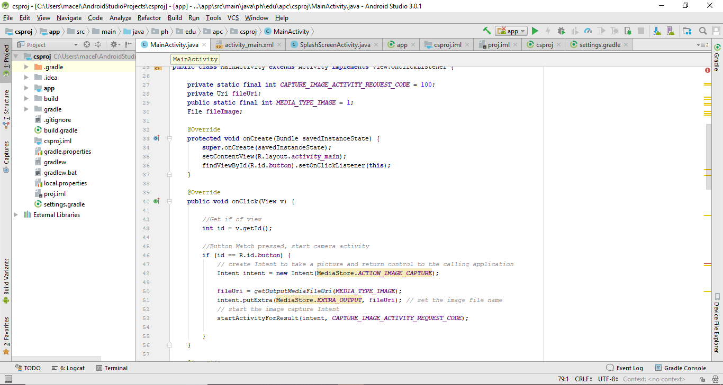Figure 27 - Splash Screen Activity (Source code)

Figure 28 - Main Activity (Source code)

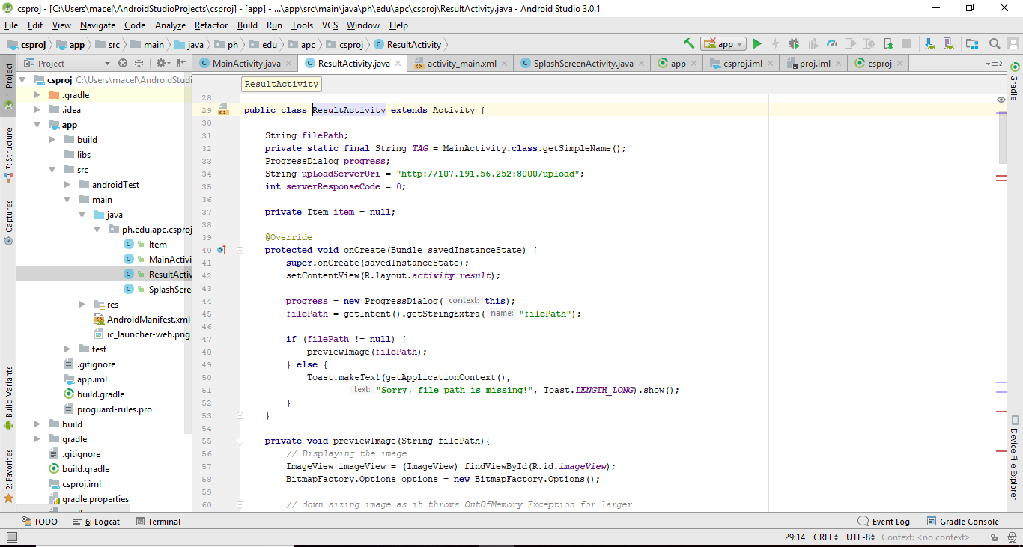

Figure 29 - Result Activity (Source code)

|  |  |  |
| --- | --- | --- |
| **Name:** | **MA. ERYEL GIANCA A. CELLS** | **A person posing for the camera  Description generated with very high confidence** |
| **Complete Address:** | 44 M. Benitez St. Gamban, Cabrera Pasay City |
| **Email Address:** | [macells@student.apc.edu.ph](mailto:macells@student.apc.edu.ph)  eryel.cells@gmail.com |
| **Contact No.:** | (0997)960-5835 |

|  |  |
| --- | --- |
| **Job Objective** | To employ my management and specialized skills for developing the finest performance and accomplishing the goal. And to perform my abilities, inventiveness, and imaginative thoughts for fulfilling the task. |
| **Education** | **Asia Pacific College**, Magallanes, Makati City  **B.S. Information Technology,**  **with specialization in Mobile and Internet Technologies**  June 2015 - Present |
| **Work-Related Courses** | * Mobile Application Development * Web Programming * Database Management * IT Project Management |
| **Academic Projects** |  |
| **Technical Skills** | * MS Office: Word, Excel, PowerPoint * Web Development: PHP, CSS, & Java Web * Mobile Development: Android Java * Database Management: SQL, Firebase * Basic knowledge in Java SE, & C++ |
| **Seminars & Trainings Attended** | * Hack to the Future, Green Sun Hotel, Makati City (March 2018) * Junior Information Systems Security Association (JISSA) General Assembly, Microsoft Philippines Office, 6750 Ayala Avenue, Makati City, Metro Manila,  (February 2018) * Hack to the Future Campus Tour,   Asia Pacific College, (September 2017)   * Defending Programming in Front-End Web Development Seminar, Asia Pacific College (July 2017) * Brief Round Table Discussion on Cyber Security,   Asia Pacific College, (March 2017)   * Youth for Leadership Summit 2016 |
| **Extra-Curricular Activities** | * Junior Information Systems Security Association (JISSA),   Vice President (2017 – 2018)   * Junior Information Systems Security Association (JISSA),  SOAR Representative (2017 – 2018) * Junior Information Systems Security Association (JISSA),   JISSA Council (2017 – 2018)   * Junior Philippine Computer Society (JPCS),   Student Member (2017 – 2018)   * Junior Philippine Computer Society (JPCS),   Student Member (2016 – 2017) |

|  |  |  |
| --- | --- | --- |
| **Name:** | **BENEDICT M. AGNO** | C:\Users\Benedict\Desktop\asd\f1.png |
| **Complete Address:** | Condominium 8 unit 5A,  Villamor Airbase, Pasay City |
| **Email Address:** | [bmagno@student.apc.edu.ph](mailto:bmagno@student.apc.edu.ph)  benedictagnot@gmail.com |
| **Contact No.:** | (0927)528-8578 |

|  |  |
| --- | --- |
| **Job Objective** | Seeking to share my skills to the people around me and to the company. |
| **Education** | **Asia Pacific College**, Magallanes, Makati City  **B.S. Information Technology,**  **with specialization in Mobile and Internet Technologies**  June 2015 - Present |
| **Work-Related Courses** | * Mobile Application Development * Web Programming * Database Management * IT Project Management * Computer Security * Cloud Programming |
| **Academic Projects** |  |
| **Technical Skills** | * Adobe Premiere and Adobe After Effects * Python for Ren’Py, The Visual Novel game engine * Microsoft Word, Excel and Powerpoint * Mobile Development, Android Studio * Database Management, SQL * Fundamental Knowledge in C++ |
| **Seminars & Trainings Attended** | * Junior Information Systems Security Association (JISSA) General Assembly, Microsoft Philippines Office, 6750 Ayala Avenue, Makati City, Metro Manila,  (February 2018) * Youth for Leadership Summit 2016 |
| **Extra-Curricular Activities** | * Junior Information Systems Security Association (JISSA),   Creative Head (2017 – 2018)   * Junior Philippine Computer Society (JPCS),   Student Member (2017 – 2018)   * Junior Philippine Computer Society (JPCS),   Student Member (2016 – 2017)   * Junior Philippine Computer Society (JPCS),   Student Member (2015 – 2016) |

# References

BadLamb. (2017, July 7). *Object Recognition - Free Computer Vision*. Retrieved from Google Play: https://play.google.com/store/apps/details?id=com.democv&hl=en

Bulletin, M. (2016, October 13). *World Site Day: "Stronger Together".* Retrieved from Press Reader: https://www.pressreader.com/philippines/manila-bulletin/20161013/281788513576598

CamFind. (2016, November 30). *CamFind visual search - powered by CloudSight.ai*. Retrieved from Itunes: https://itunes.apple.com/us/app/camfind-visual-search-powered-by-cloudsight-ai/id595857716?mt=8

Mapua. (2016, September 20). *Investing in the Future: The IT Industry of the Philippines*. Retrieved from Cardinal Blog: https://www.mapua.edu.ph/blog/2016/09/20/top-it-school-manila-mapua/

Palmer, J. J. (2013, January). *Computer Education in the Philippines.* Retrieved from Questia: https://www.questia.com/library/journal/1G1-13469486/computer-education-in-the-philippines

Reyes, R. R. (2017, April 22). *Makers of app for the color blind wins top Microsoft award*. Retrieved from Business mirror: http://www.businessmirror.com.ph/makers-of-app-for-the-color-blind-wins-top-microsoft-award/

Team, M. P. (2017, September 18). *Microsoft launches video that shows an example of how technology can empower students with special needs.* Retrieved from Microsoft: https://news.microsoft.com/en-ph/2017/09/18/microsoft-launches-video-shows-example-technology-can-empower-students-special-needs/

Tukrel, A. (2016, July 22). *iDentifi- Object Recognition for Visually Impaired* . Retrieved from App Store : https://itunes.apple.com/us/app/identifi-object-recognition-for-visually-impaired/id1135223189?mt=8

Wolfram, S. (2015, May 13). *Wolfram Language Artificial Intelligence: The Image Identifier Project*. Retrieved from Stephen Wolfram Blog: http://blog.stephenwolfram.com/2015/05/wolfram-language-artificial-intelligence-the-image-identification-project/